MSFS Step by Step Guide

Single PC (multiple channels/views per PC) MSFS multi-view data. The multi-view data contains the needed parameters to configure the view orientation and the horizontal/vertical Field of View (FOV) for each view.

Current MSFS implementation supports only one FOV value for all views per PC. However, on a Single-PC setup with more than one view, all views have to have the same FOV.
IMPORTANT: When exporting multiple views for Single-PC, ALWAYS make sure that Same FOV is selected and checked to ensure all views have the same FOV.
IMPORTANT: MSFS does NOT support asymmetric frustums. ALWAYS make sure Asymmetric frustum is turned OFF before you calculate and export the perspective view data.
IMPORTANT: The current multi-view MSFS export has a limitation of Vertical FOV between 26 degrees and 104 degrees. Any design which produces Vertical FOV out of this range will not be able to be exported and needs to be re- designed.
Additional “Reuse Default MSFS View” option is only available for Single-PC setups. When selected, the exported view data will include the view parameters for the main MSFS window for the first view and each additional view will be configured using the MSFS experimental multi-view window. This makes optimal use of the MSFS windows.
However, if the main window is to be used for some other rendering (example maps, instruments, etc...), then the option “Reuse Default MSFS View” can be disabled. In that case, each view will be opened on a separate multi-view window and the main window can be used for the menus and other rendering.
The MSFS export will export the files “msfs_multiPC.txt” and “msfs_singlePC.txt” respectively which contain information about the views and how to setup the views in MSFS

It is needed to locate and modify the camera.cfg file in the Airplane folder.
IMPORTANT: The required changes must be made per airplane
The Airplane folders can be found in the MSFS Official or Community packages folders.
Example: The Asobo default C172sp airplane (for Steam installs) can be found
here:
<MSFS_INSTALL>\packages\Official\Steam\asobo-aircraft-c172sp-
classic\SimObjects\Airplanes\Asobo_C172sp_classic
Locate and make a backup copy of the cameras.cfg file. You will need to open and modify this file according to the exported data.
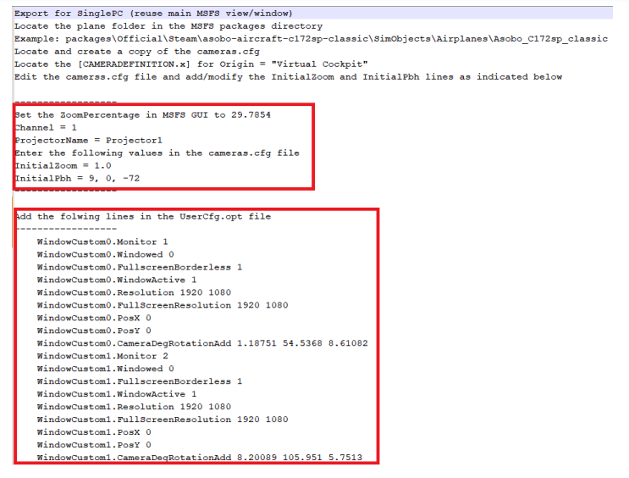

Locate the Camera definition for the Pilot Virtual Cockpit and apply the following mandatory changes:
[CAMERADEFINITION.0]
Title ="Pilot"
Guid ="{195EAB58-9E4A-1E2A-A34C-A8D9D948F078}"
Description =""
Origin ="Virtual Cockpit"
...
InitialZoom = 1.0;
InitialPbh = p, b, h;
...
Where the p, b, h are the values from the exported files.
Additionally, if you would like to move the position of the view use the line eyepoint from the opt of the file to adjust the eye point position.
[VIEWS]
eyepoint = -3.95, -0.85, 1.9 ; (feet) longitudinal, lateral,
vertical distance from reference datum
For Single-PC (Multiple channels/views per PC), in addition to setting up the cameras.cfg file for the desired plane, the exported “msfs_singlePC.txt” file contains additional information on how to setup the additional views.
Although the MSFS GUI supports visually adding new view windows and editing of the lateral, vertical and roll offers for each window, the GUI functionality has a number of bugs and limitations (number of decimal places) which makes it not suitable for GUI editing.

The exported msfs_singlePC.txt contains the exact data to be copied in the UserCfg.opt configuration file. This file contains the exact definition of the additional views in MSFS.
Locate and make a backup of the UserCfg.opt file in the %APPDATA%\Microsoft Flight Simulator folder.

Open the UserCfg.opt, locate the {Video section and remove any lines starting with WindowCustom. Then insert the exported WindowCustom lines from the exported msfs_singlePC.txt file.
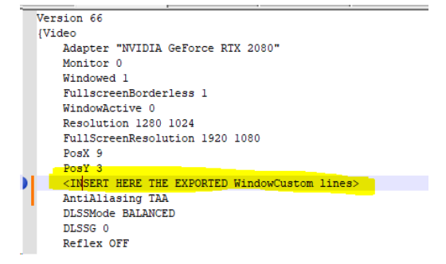

Additionally, you can edit and change the WindowCustom0.Monitor, WindowCustom1.Monitor, etc. values to position to additional windows on the correct PC output. This can also be done in the GUI by making the view window non-full screen (ALT+ENTER), moving the window to the desired output and making the window full screen (ALT+ENTER).
The views FOV data is encoded in the ZoomPercentage value. Check the next sections on how to set and ensure the ZoomPercentage value in Immersive LCD PRO .

Setting up the MSFS zoom

In order to ensure a stable and accurate ZoomPerentage, include a SimConnect client which connects to the MSFS instance on the same PC and makes sure that exported ZoomFactor is always applied to MSFS Virtual Cockpit view. Even when changing views or ZoomPerentage in the GUI, the desired ZoomPerentage will be set and enforced correctly by both Immersive LCD PRO and Immersive Display PRO software. This is required for both a Single-PC multi-view and Multi-PC multi-view setups.
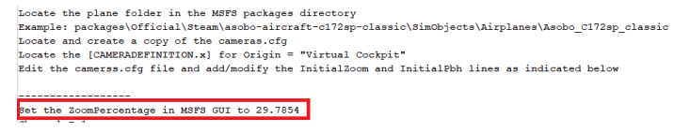
Locate the line with the ZoomPercentage from the exported “msfs_multiPC.txt” and “msfs_singlePC.txt” and copy the ZoomPercenatge value.
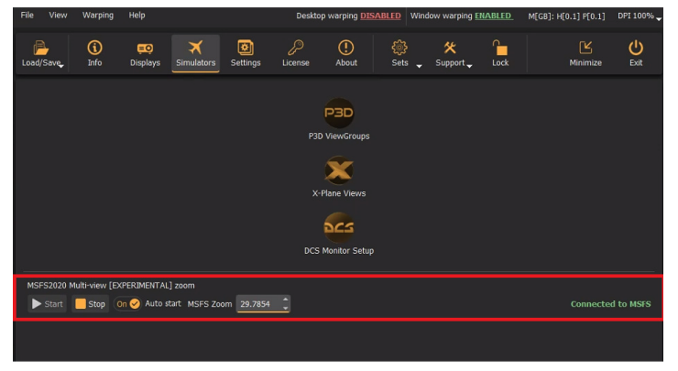
Open the Immersive Display PRO window and enter the exported Zoom value in the Simulators tab . Press on Start (or enable auto-start) to start SimConnect client which will connect to MSFS and make sure the entered Zoom value is always applied in MSFS.

Setting up the MSFS cockpit mode
By default, MSFS has some camera options enabled that will change the view orientation and will mess up with the geometrical correction and edge- blending. To prevent any view changes, make sure that the CAMERA SHAKE option is turned OFF and the HOME COCKPIT MODE is turned ON.

Removing the virtual cockpit
Although the HOME COCKPIT MODE documentation suggests that when this option is enabled the Virtual Cockpit will not be drawn, the current and the latest version of MSFS contains a bug and the interior and exterior are still drawn even when HOME COCKPIT MODE is enabled. This is undesirable with simulator setups with its own cockpit and when the visual system only needs to project the outside views (and not the virtual cockpits and other exteriors).
Fortunately, there is another way to remove the rendering of the interior and/or exterior of the aircraft. Locate and make a copy of the SimObjects model.cfg file for the particular aircraft.
Example: The Asobo default C172sp airplane (for Steam installs) can be found
here:
<MSFS_INSTALL>\packages\Official\Steam\asobo-aircraft-c172sp-
classic\SimObjects\Airplanes\Asobo_C172sp_classic\model\model.
cfg
Edit the file and put the “;” (semicolon) before exterior and interior lines to comment out the lines. This will remove them from the rendered views.

Final setup
There is one more step. Just load the exported multi.procalib files in Immersive Display PRO.
Start MSFS in full screen mode and make sure that the main view and the additional views are positioned on the correct video output display.

